Isolate an image and change the color

BEFORE | AFTER
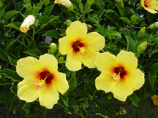 | 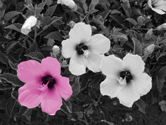

Step 1: Using the sample photo provided, open the image in GIMP.
Step 2: Using the Intelligent Scissors Tool , select the flower in the lower left of the photo. (See facilitator if you need help using the tool).

Step 3: To remove the color from the remainder of the photo, choose SelectInvert
Now everything but the flower is selected.

Next, ColorsDesaturate This will remove the color from the picture except for the flower in the lower left.

Step 4: To re-select the flower, SelectInvert
Now we will work on changing the color of the flower.

Step 5: ColorsColorize (Set the values to match the image below)

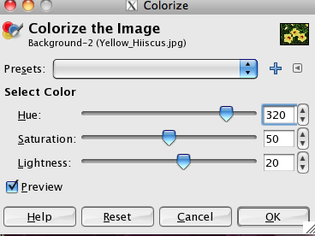 then click OK

Step 6: SelectNone

Step 7: Save Image as colorize.jpg and post to your digital photo page of your student Weebly site.

